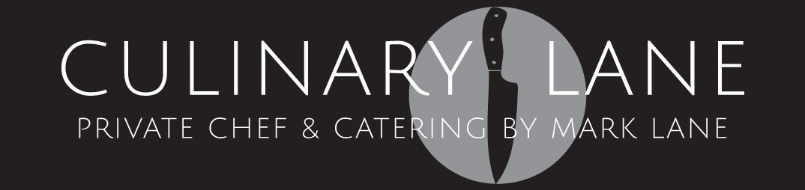
www.culinarylane.co.nz
culinarylane@gmail.com
Ph 022 400 3001

Culinary Lane Working Lunch Menu Items
Minimum order of 15 pax
Any 4 items $25.50 per head
Any 5 items $29.50 per head
Any 6 items $33.50 per head
Any 7 items $37.50 per head
(All Guests have the same items unless dietary request)

These can also be individually boxed for lunch on the go at a $2.00 extra charge per box. All items served cold
(served in disposable containers)

Please advise of any special dietary requirements at your time of booking
>Delivery, set up & crockery pick up $20.00 (Rodney)
>All prices include GST.
>Available Monday to Sunday

Cold Items
- Savoury Muffin: Roasted peppers, caramelized onion, tomato, feta & Italian parsley
- Sweet Muffin: Mixed Berry & cream cheese or Double chocolate
- Pork Belly Bap: Five spice slow roasted pork belly w- Asian slaw & sweet chili mayonnaise
- Ham Focaccia: Honey glazed ham w- slow roasted tomato, caramelized onion, cheddar, baby spinach & house made piccalilli pickle
- Chicken Ciabatta Roll: Free range chicken w- rocket, egg mayonnaise, cucumber ribbons & tomato
- Roasted Veggie Bap: House roasted vegetables, cheddar cheese, tomato, baby spinach & fresh herb cream cheese
- Veggie Club Sandwiches: Egg mayonnaise w- tomato, cucumber ribbons, cheddar & alfalfa sprouts
- Veggie Slider: Roasted field mushroom, seared halloumi, caramelized onion, balsamic beetroot & tomato relish
- Tuna Wrap: Tuna, quinoa, Asian slaw, sprouts, lemon & herb mayo in soft flour tortilla wrap
- Chicken Caesar Wrap: Free range Chicken, bacon, egg, parmesan & cos lettuce in soft flour tortilla wrap.
Hot Items (may require reheating)
- Dukkah spiced Moroccan beef skewers w- tzatziki
- Thai chicken satay skewer w- spiced peanut sauce
- Individual duck confit, caramelized onion, roasted vine ripened tomato and soft goats cheese tart
- Mushroom, butternut pumpkin and parmesan arancini w- dipping sauce
- Tomato, spinach and parmesan arancini w- dipping sauce
- Seared Thai fish & prawn cakes w- a spiced coconut sauce
- Individual bacon, onion, parsley & cheddar quiche
Individual spinach, caramelized onion a feta quiche
Individual chicken, mushroom, bacon & thyme pie
Individual beef mince, cheddar & potato top pie

Individual Gourmet Salad in noodle boxes
- Beef Moroccan Cous Salad w- seared beef, Spanish onion, garlic, raisins, red peppers, Kalamata olives, sundried tomatoes, fresh coriander, roasted almonds, olive oil & housemade Moroccan spice
- Chicken Caesar Salad w- free range chicken, baby cos, shaved parmesan, crisp bacon, crostini, anchovy & Caesar dressing
- Chicken Thai Noodle Salad w- free range chicken, bok choy, red peppers, spring onion, bean sprouts, cherry tomatoes, button mushrooms, coriander & a Vietnamese dressing
- Brown Rice Salad w- organic brown Jasmine rice, broccoli, cauliflower, roasted capsicum, red onion, almonds & sweet soya dressing
- Roasted Italian Vegetable Salad w- red quinoa, eggplant, capsicum, field mushroom, courgette, red onion, fresh basil & a balsamic dressing
- Mixed Leaf Salad w- baby leaves, tomatoes, spring onions, cucumber, sprouts, fresh herbs, red peppers, carrot & mustard honey dressing

Sweet Items
- Chefs’ selection of housemade sweet slices
- Double chocolate brownie
- Lemon slice
- Caramel & macadamia slice
- Ginger crunch
- Muesli Slice
- Carrot cake w- cream cheese icing & walnuts
- Banana bread & lemon cream cheese
- Fresh fruit skewers w- berry Greek yoghurt

